
Create a Declarative Jenkins parameterized pipeline for simplecustomerapp.
Requirements:
- Create a Pipeline job in Jenkins.
- Use a Git repository for simplecustomerapp.
- Add parameters:
• BRANCH_NAME (string, default: main)
• ENV (choice: dev, qa)
- Define environment variables:
• APP_NAME = simplecustomerapp
- Implement stages:
• Checkout (based on BRANCH_NAME)
• Build (mvn clean compile)
• Test (mvn test)
• Package (mvn package)
- Add post actions:
• Success → print success message with environment
• Failure → print failure message
- Trigger using Build with Parameters.
 Outcome
• Parameterized Jenkins pipeline created
• Code is built, tested, and packaged automatically
• JAR file generated in target/
• Clear visibility of build stages and logs
• Single pipeline works for multiple environments
 Advantages
• One pipeline can be reused for different branches and environments
• Reduces manual build and deployment effort
• Early test failures stop bad code from moving forward
• Easy to maintain and extend (SonarQube, Docker, Deploy stages later)

Step by Step Implementation:
Navigate to AWS and Click on EC2 and click on launch instances
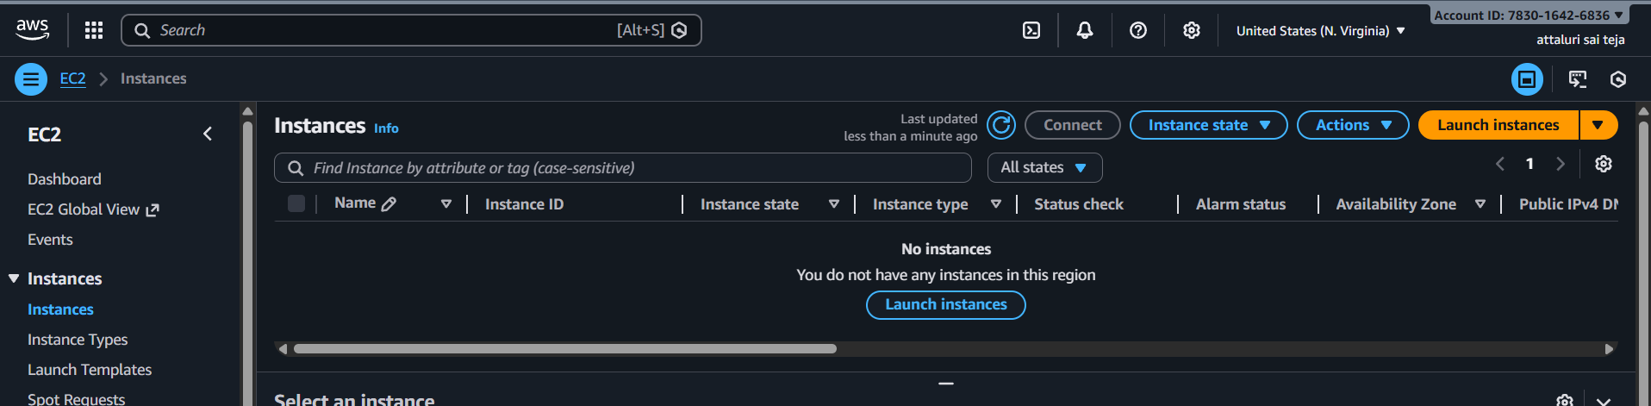
Select the configuration
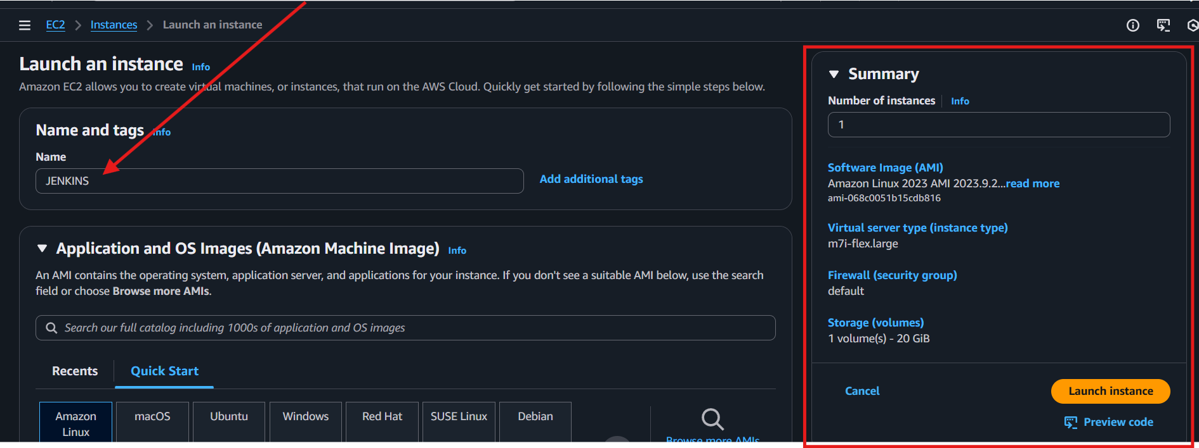
After clicking on launch instance then a newly instance is been launched
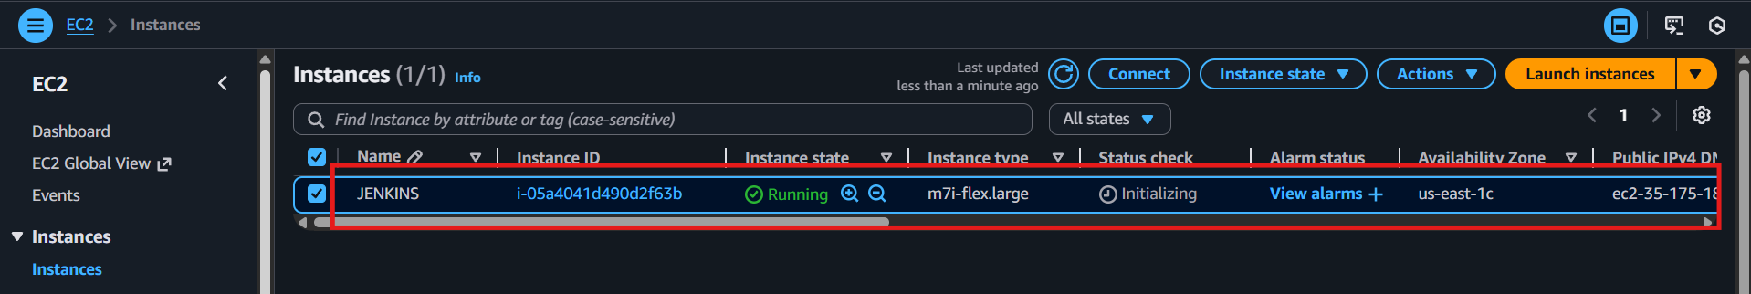

After that click on connect tab to connect via browser
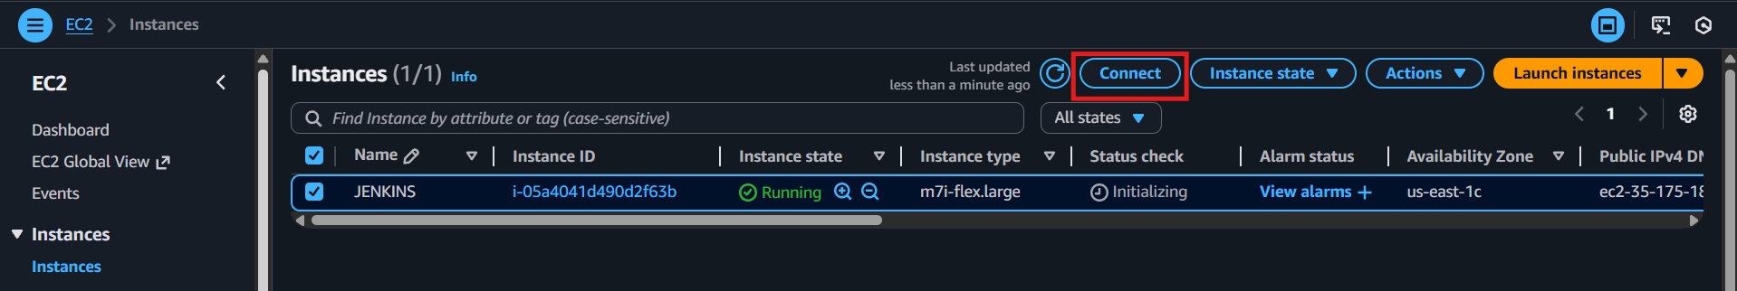
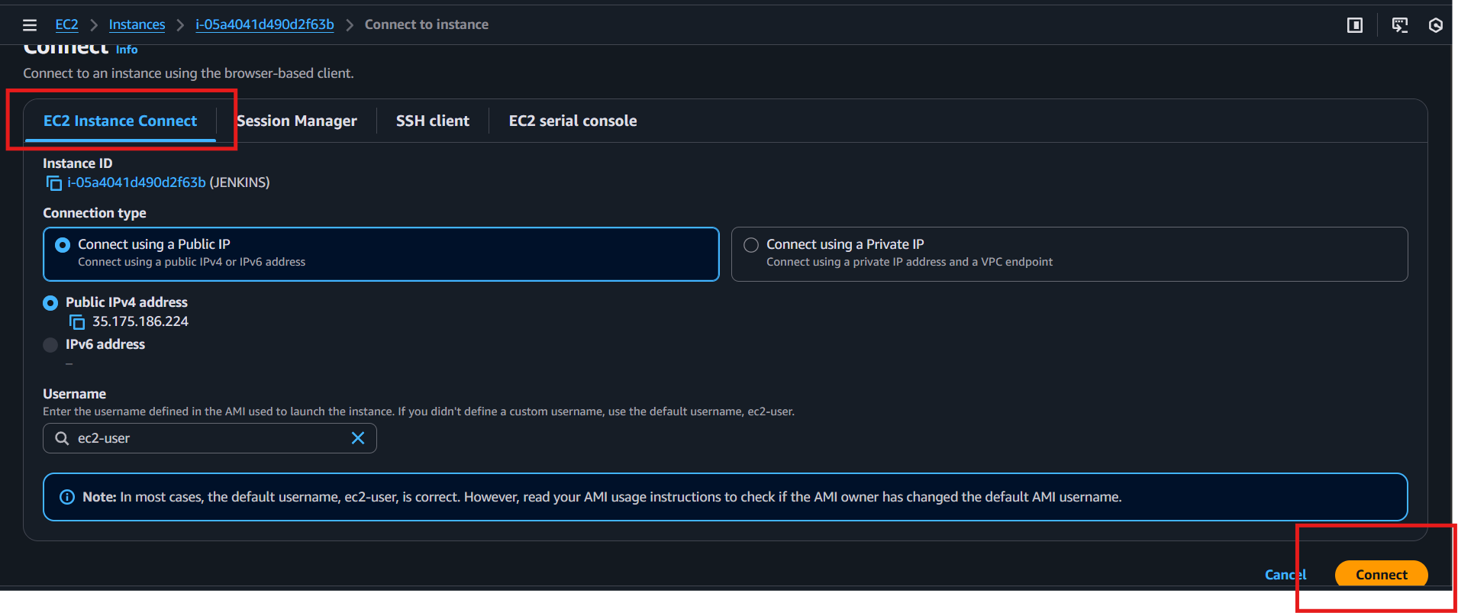
Using ec2 instance connect to connect with our ec2 in browser
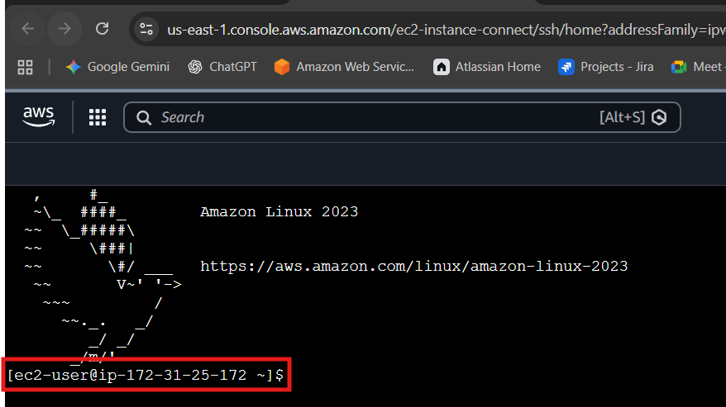

Then change the user ec2-user to root/
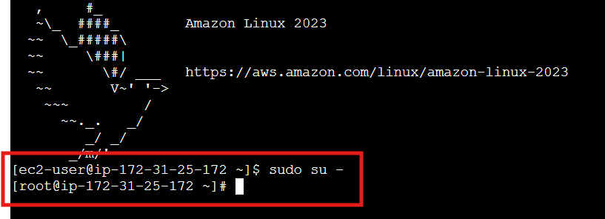
Then open new tab and search for Jenkins.io and get the downloading details from website
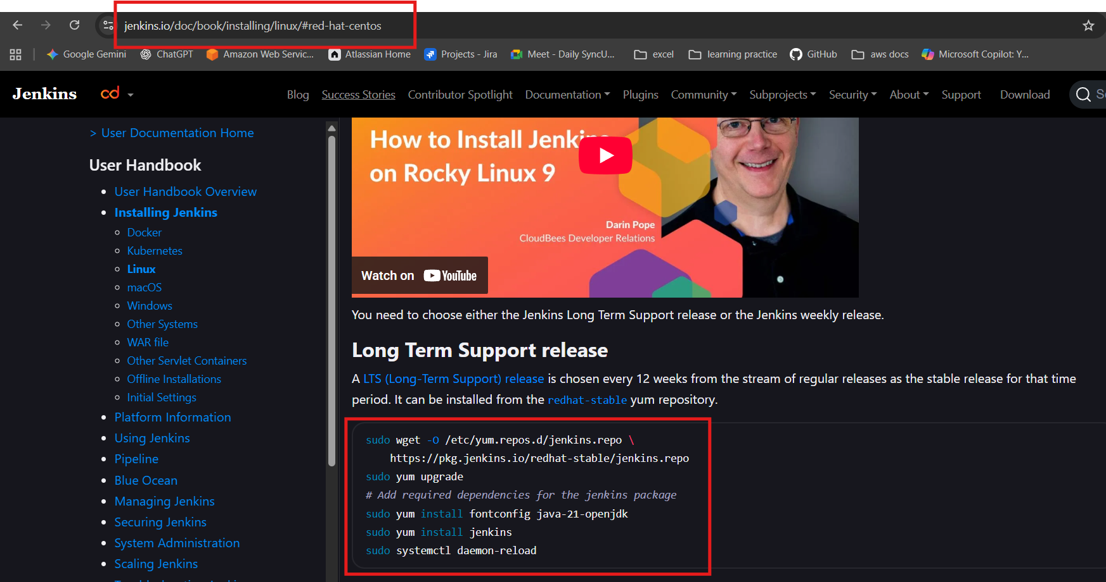
And execute them in order
Many version will provided select accordingly to your java version
In the above commands list a command is also provided for java installation
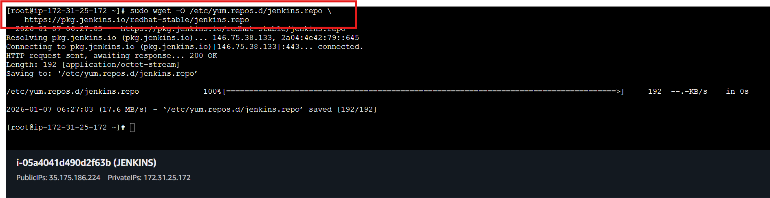

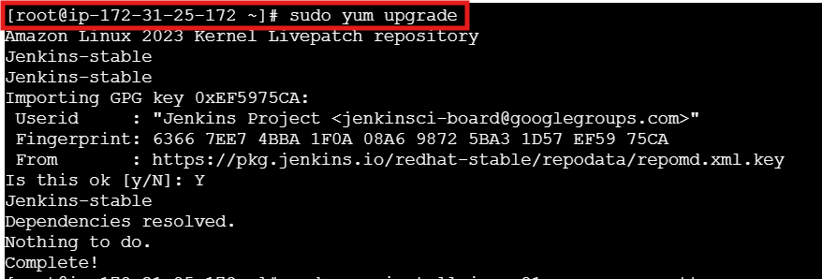
The java version is getting downloaded
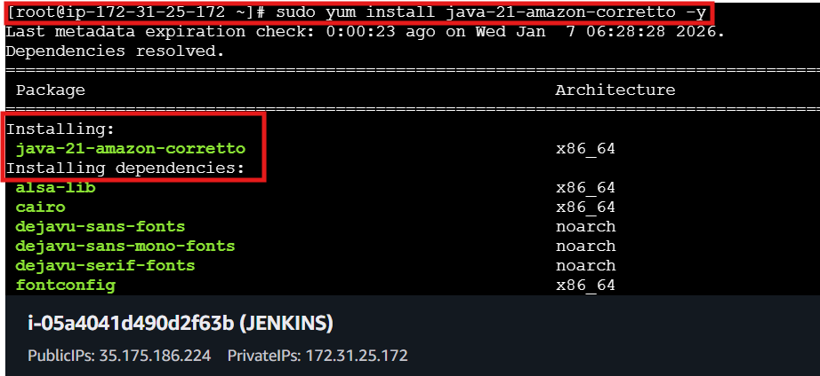
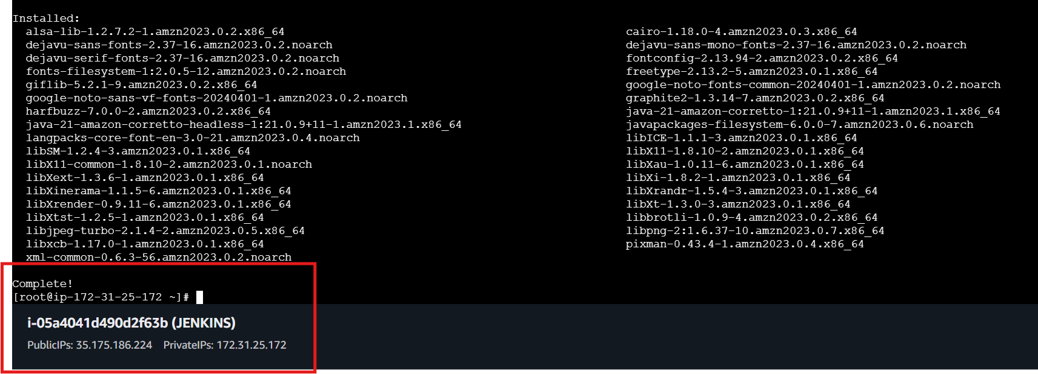

After getting the binaries and rpm packages install Jenkins in master machine or main
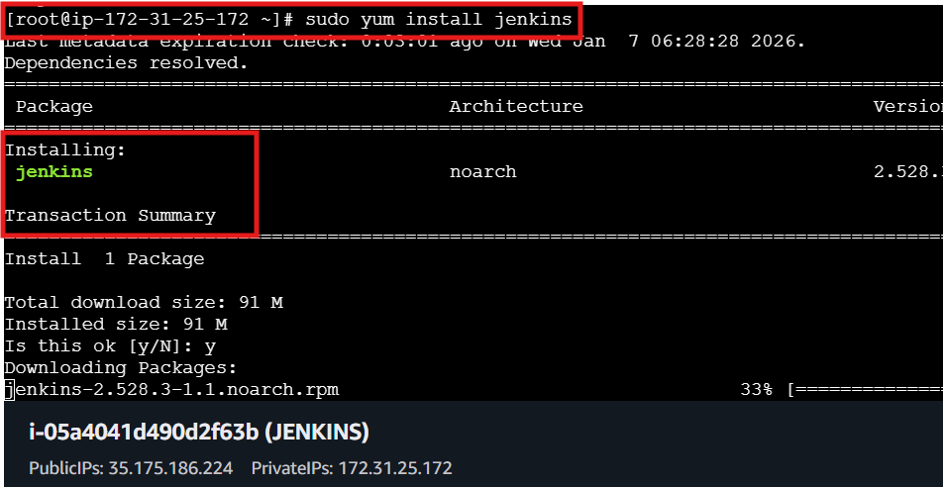
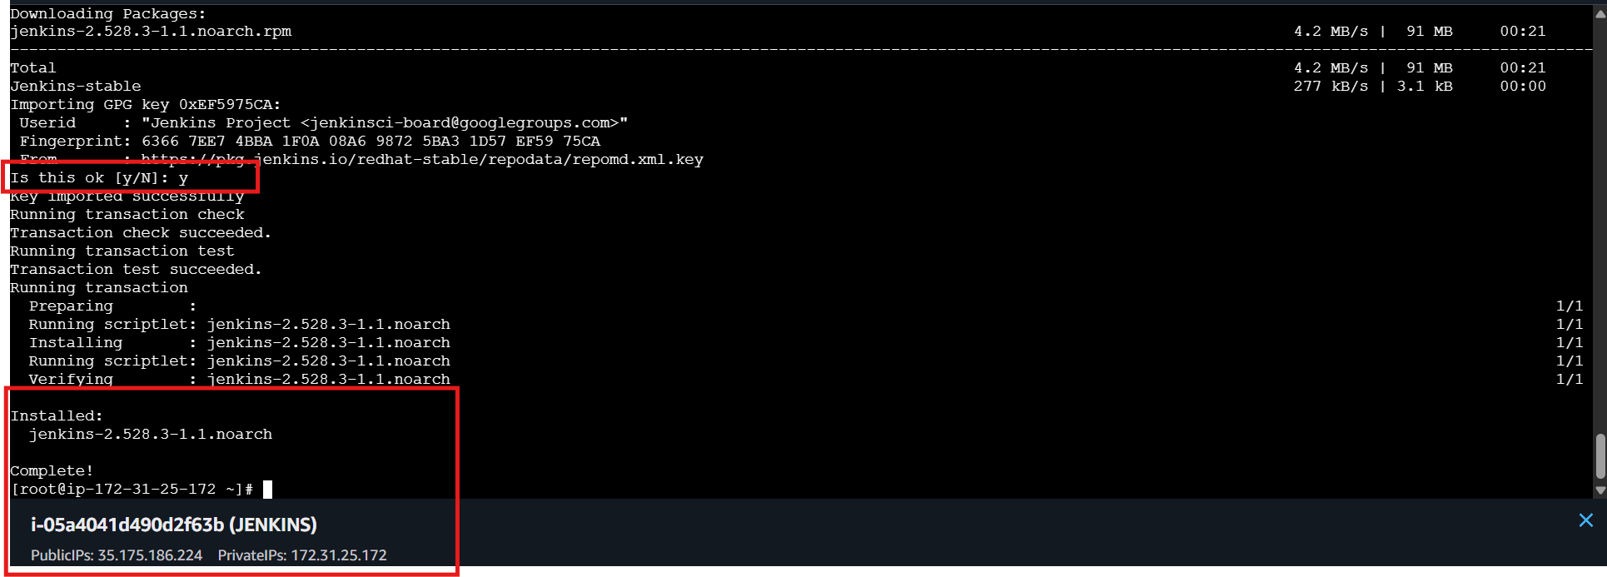
The best practice is to do the daemon reload without shutdown and start the services
It will restart the service within seconds
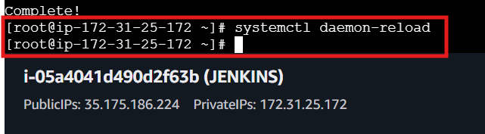

After that start jenkins
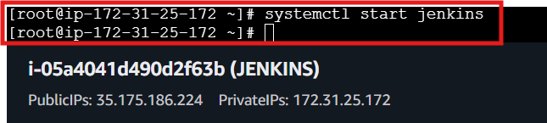
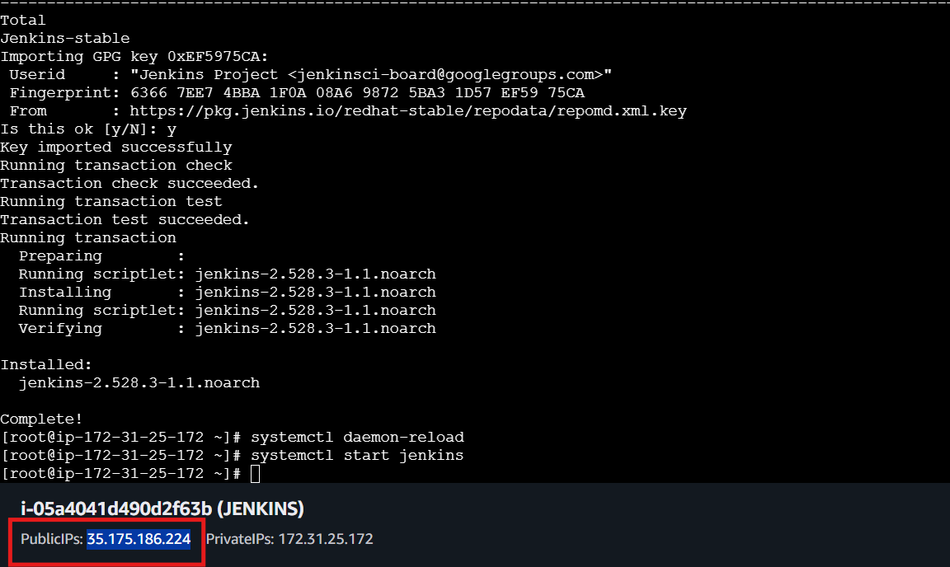
Connect In browser using public ip:port number
And a initial admin password need to enter and highlighted the path so you can find it from the location in cli
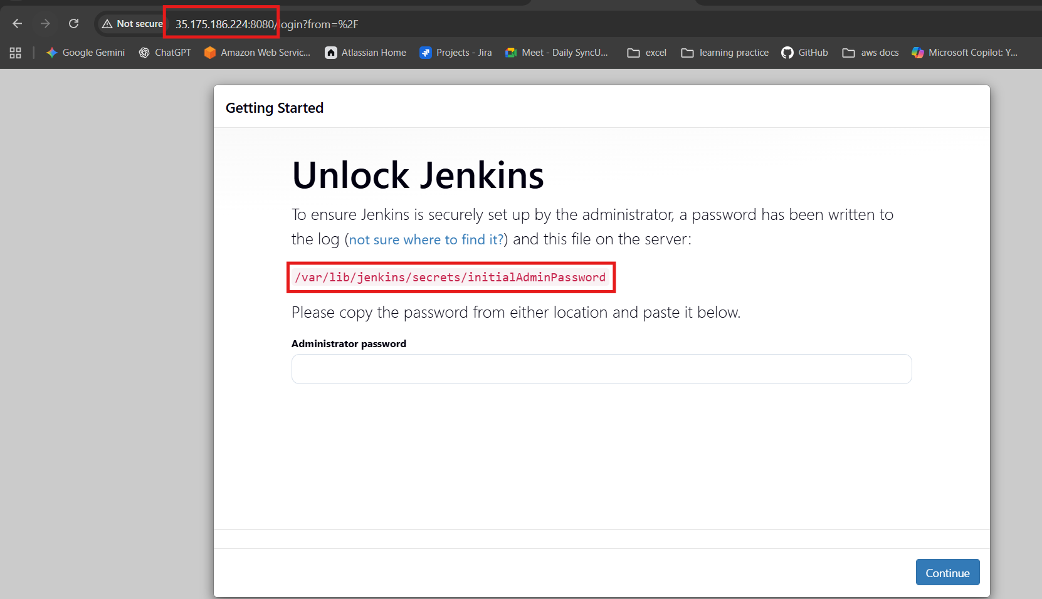
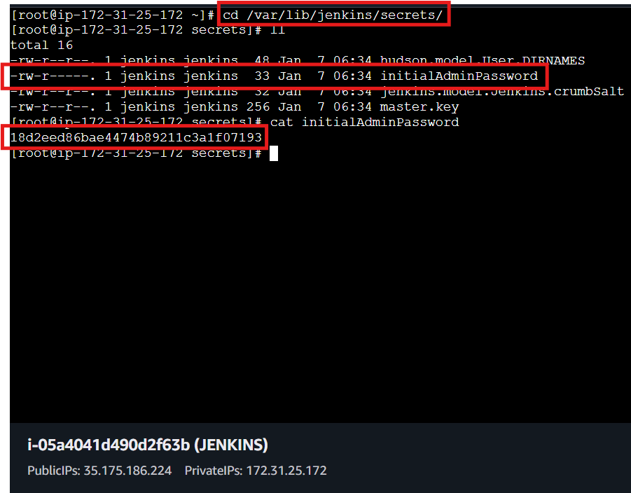
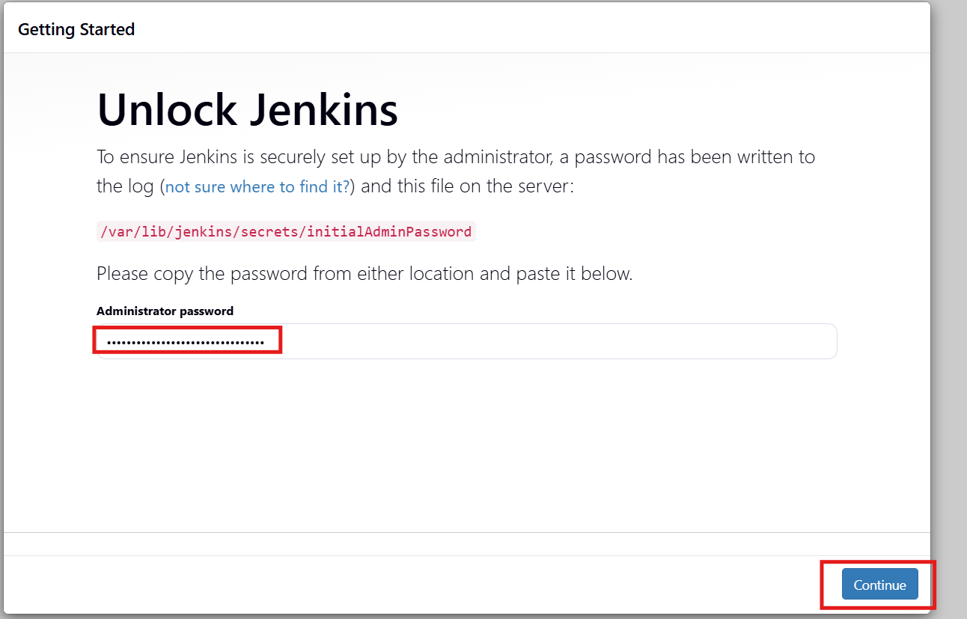

After entering the password select the install suggested plugins by jenkins
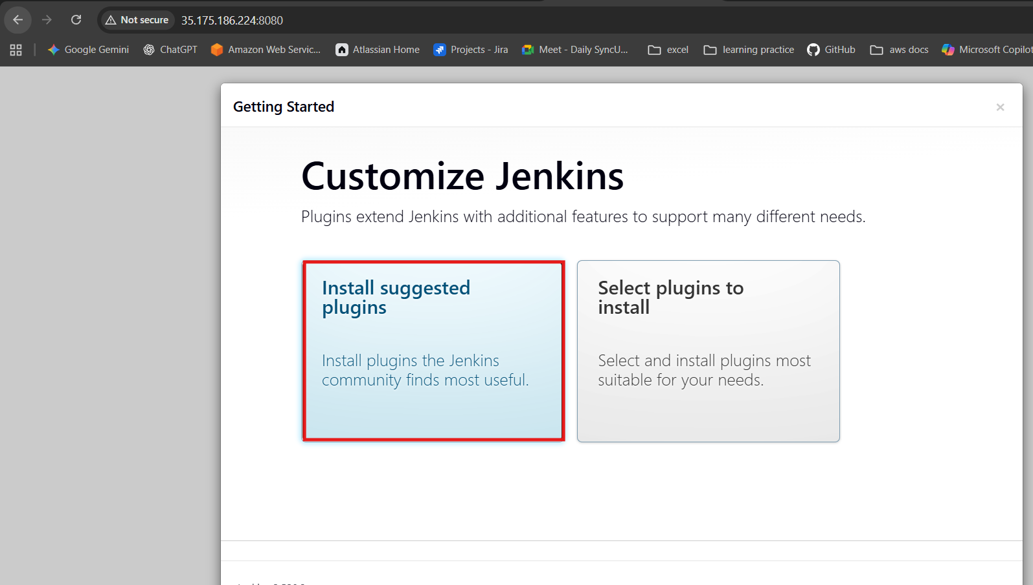
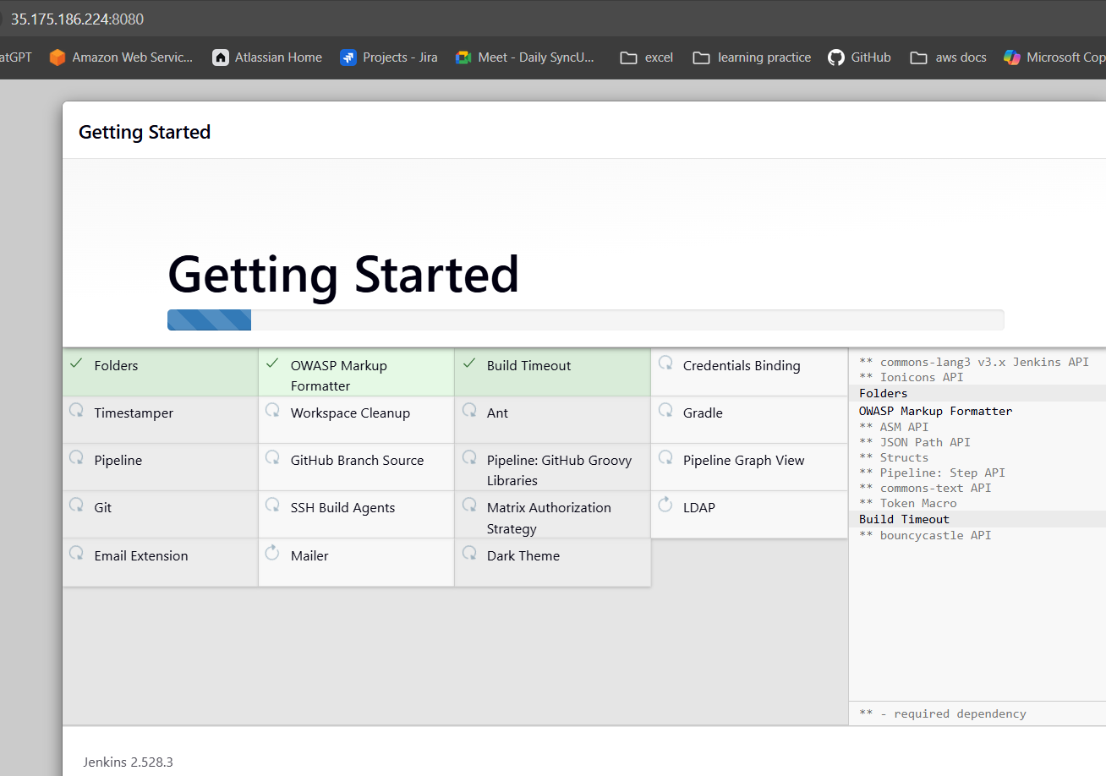

After that you will be asked to create a admin user provide name and password that wont forgettable
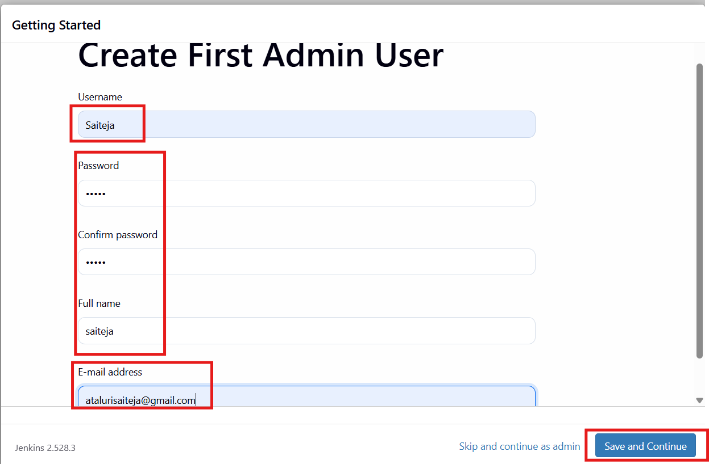
Later confirm the url and continue
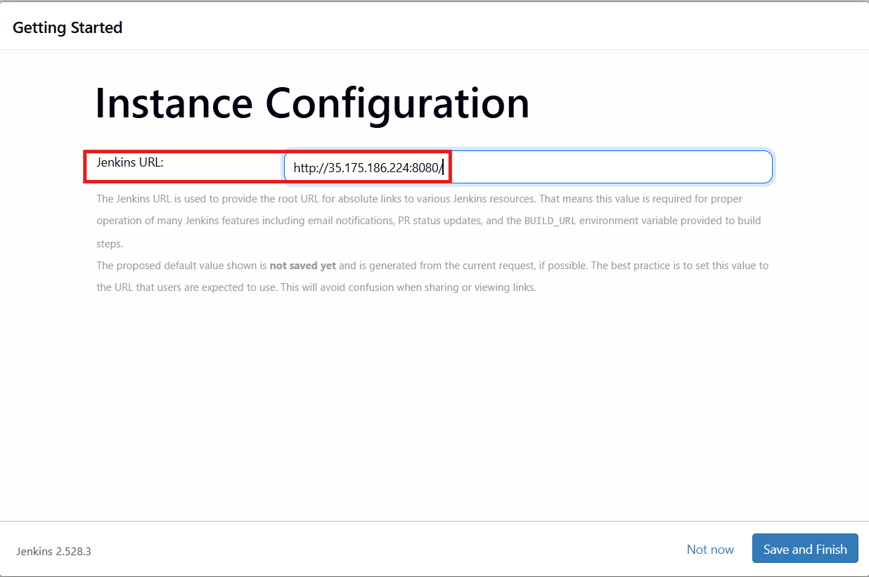
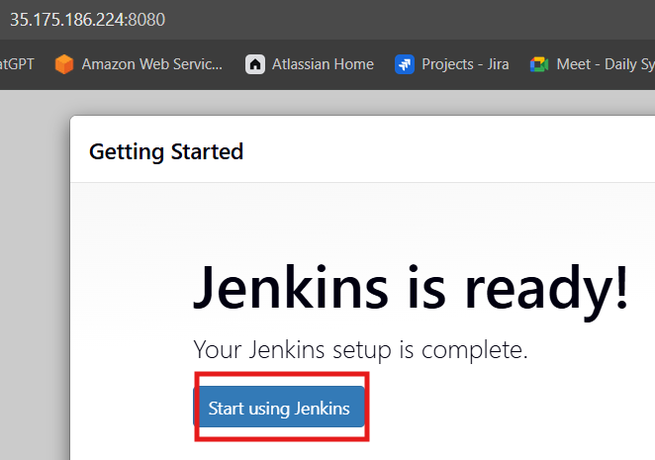
The dashboard of Jenkins look like this
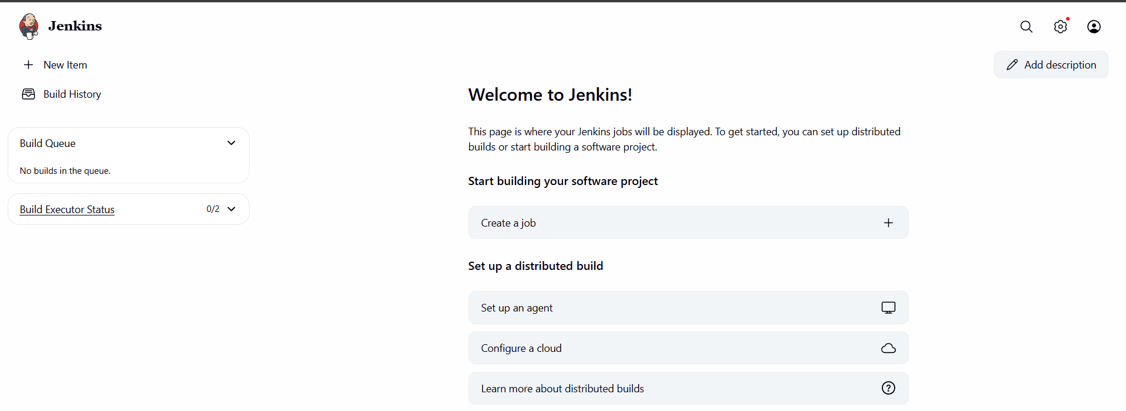

Later we need to install maven and it is used to build tool then goto official maven website and copy the link and use the command wget to download the binaries
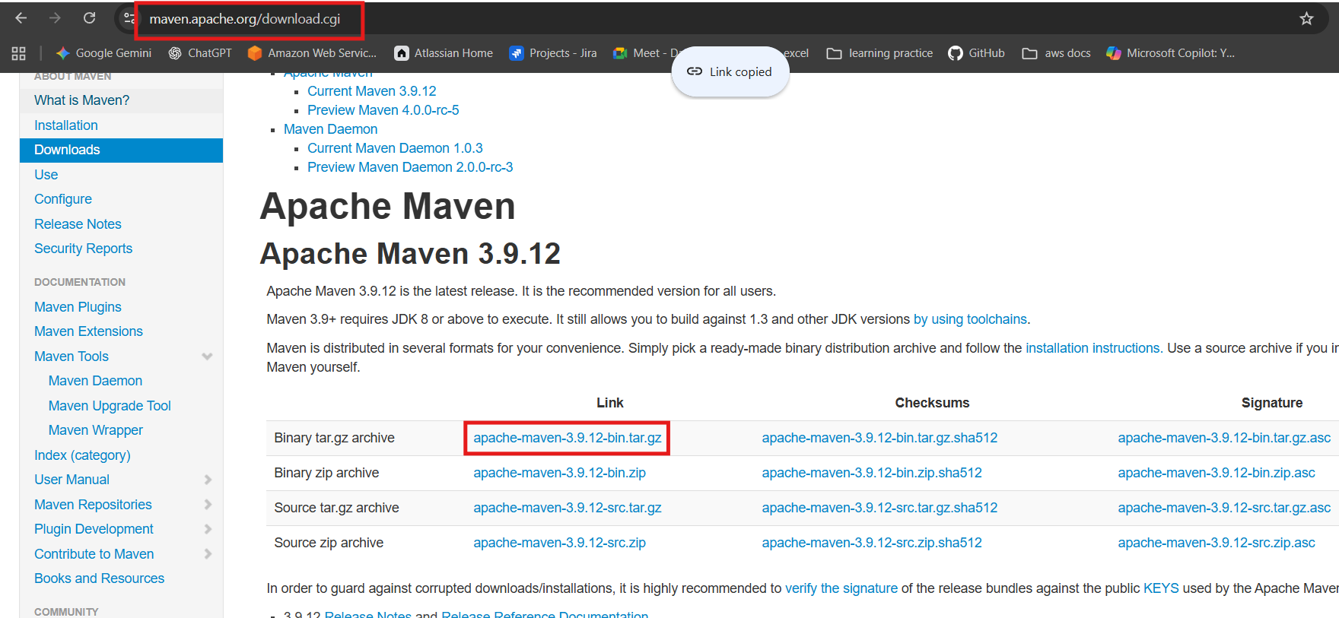
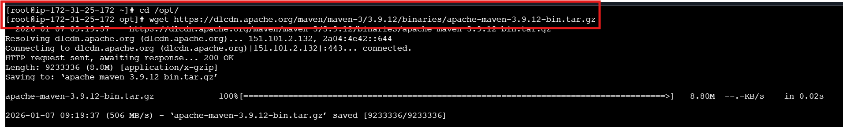
After that extract the files using tar command
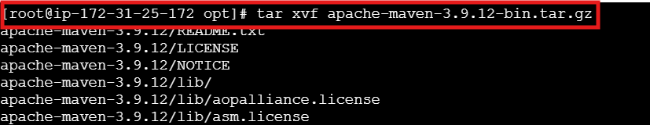
Change the directory to apache and install the maven service
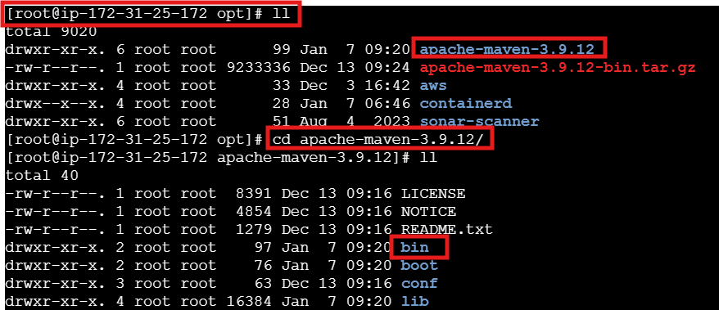
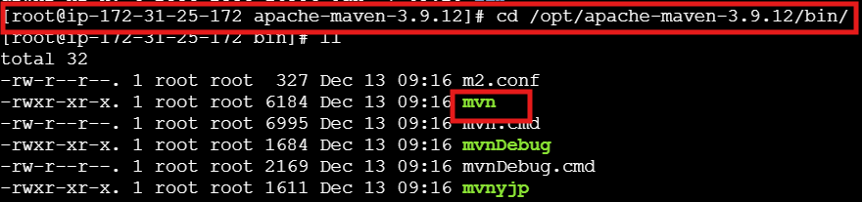
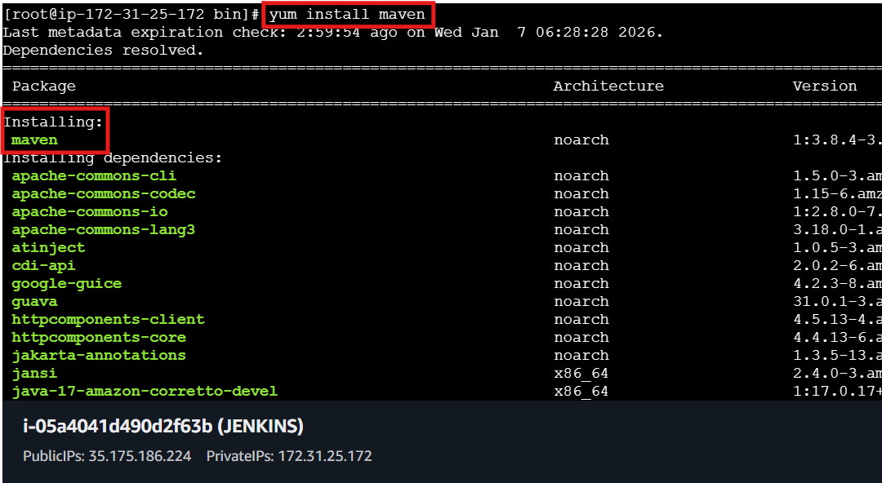
After that we can verify the maven version from bin location not from other location so that edit .bash_profile file and insert the data so that mvn is available
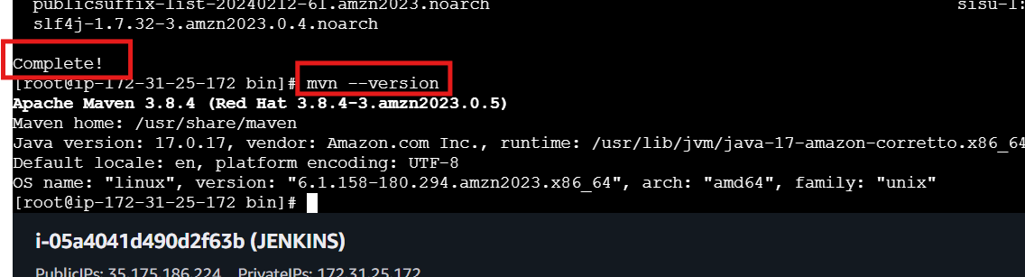

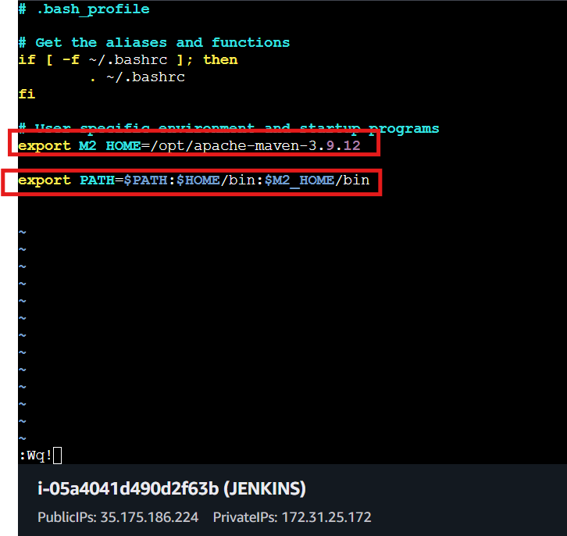
Source ~/.bash_profile is used to refresh the file
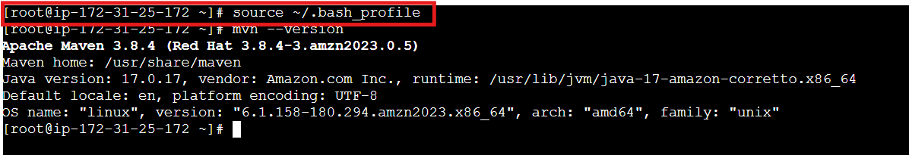

In the Jenkins server go to settings and select the plugins and install maven plugin
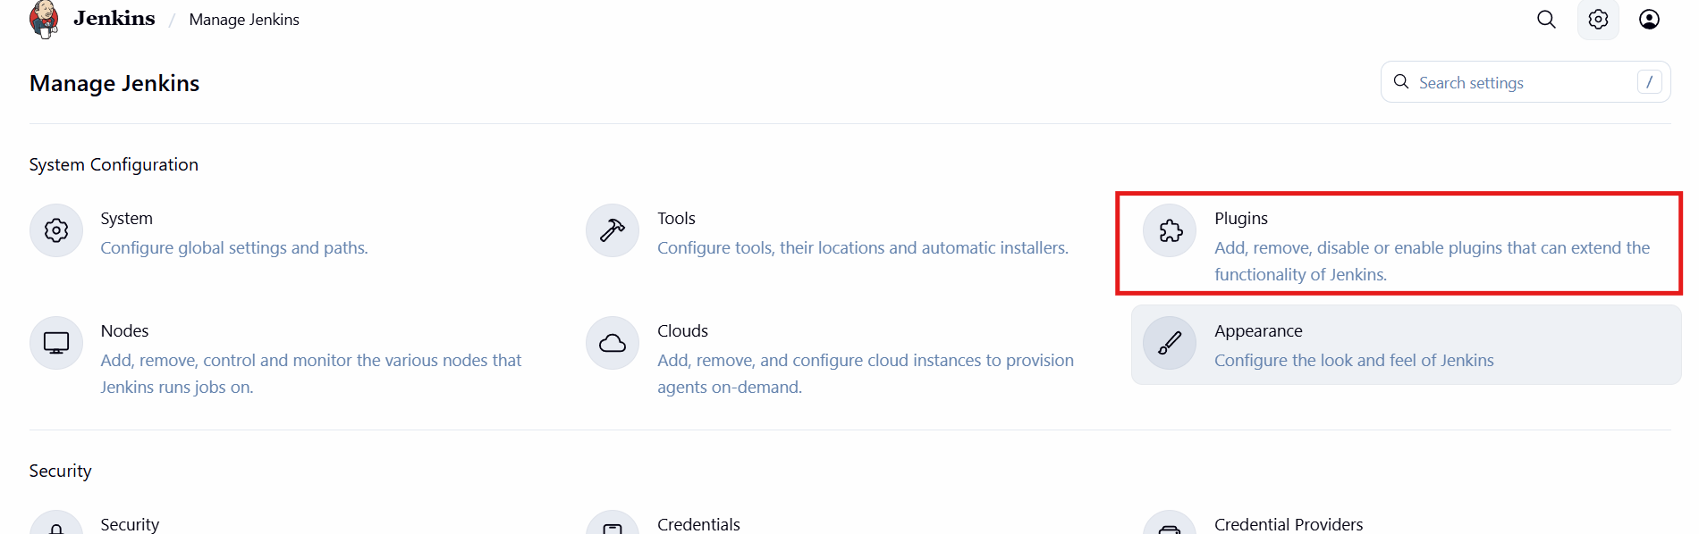
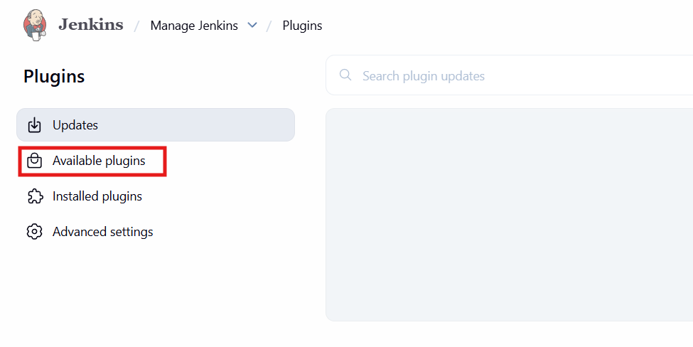
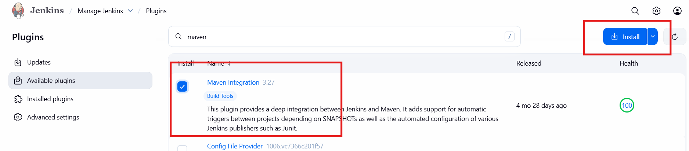
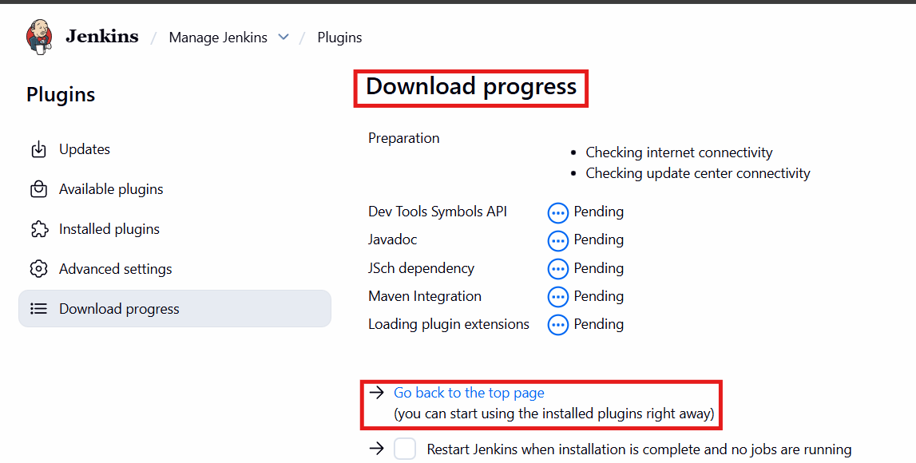
Again navigate to tools and add maven details the same which we provided in bash_profile file
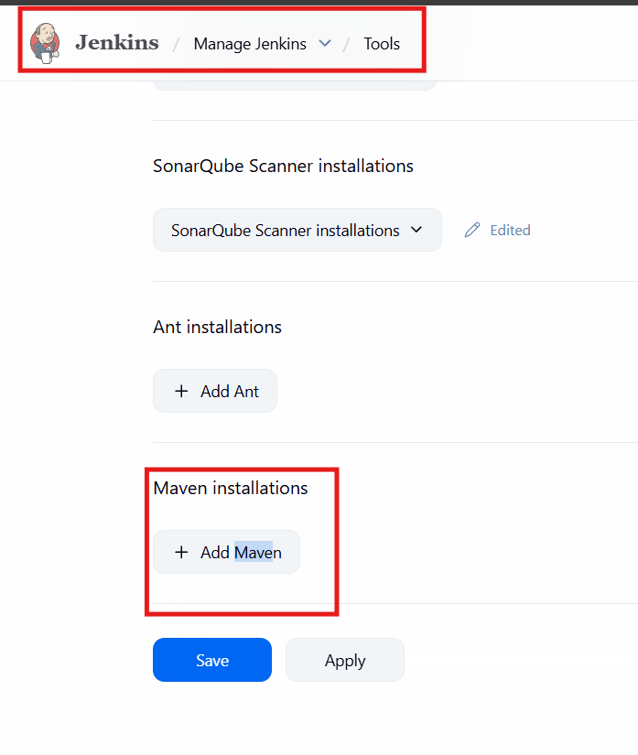
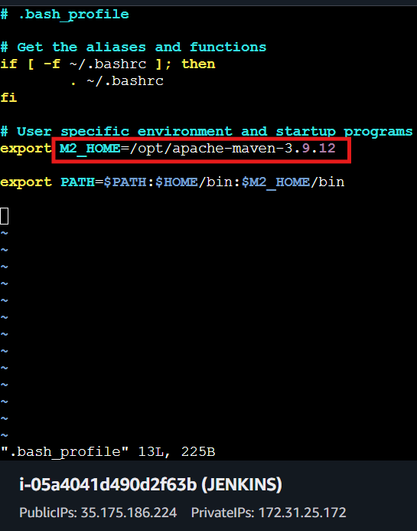
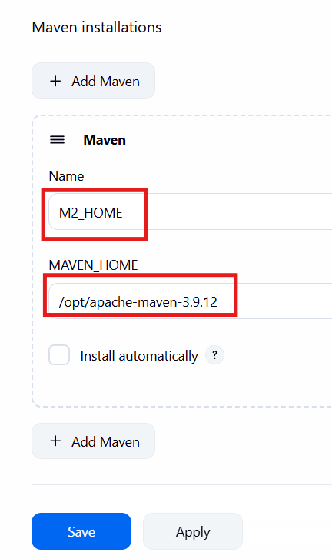

After the configuration click on new item to create a new job and continue by creating using below images
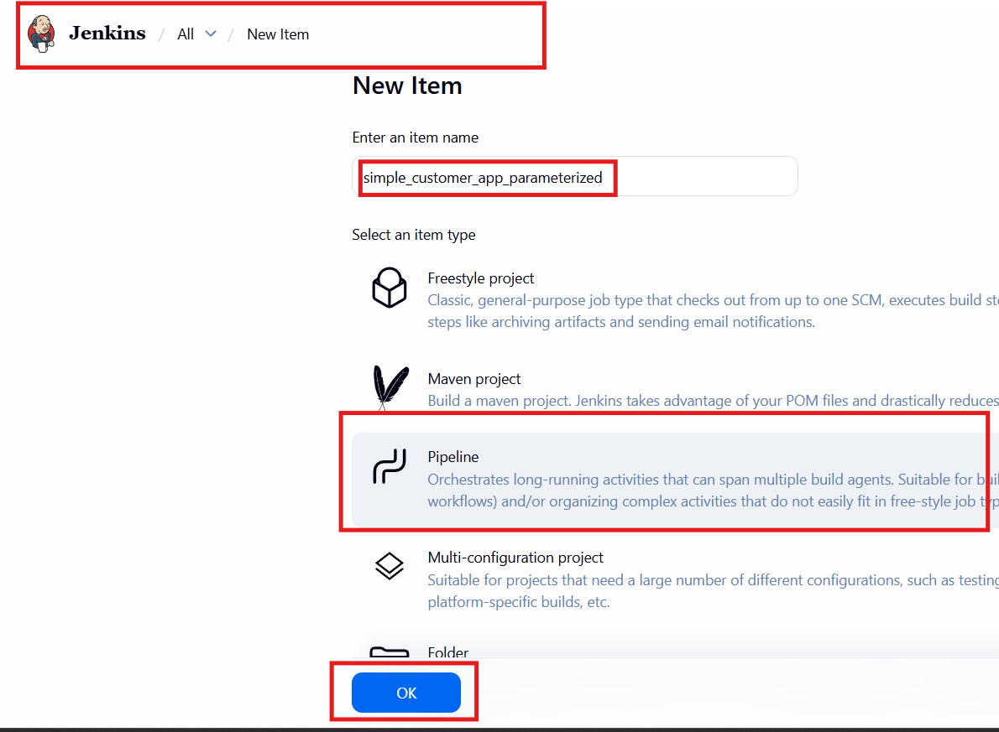
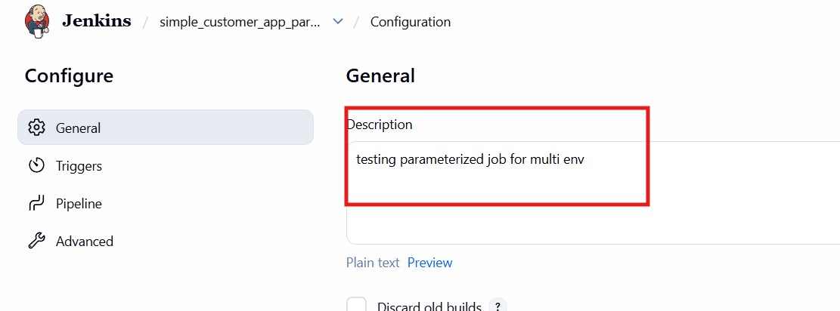
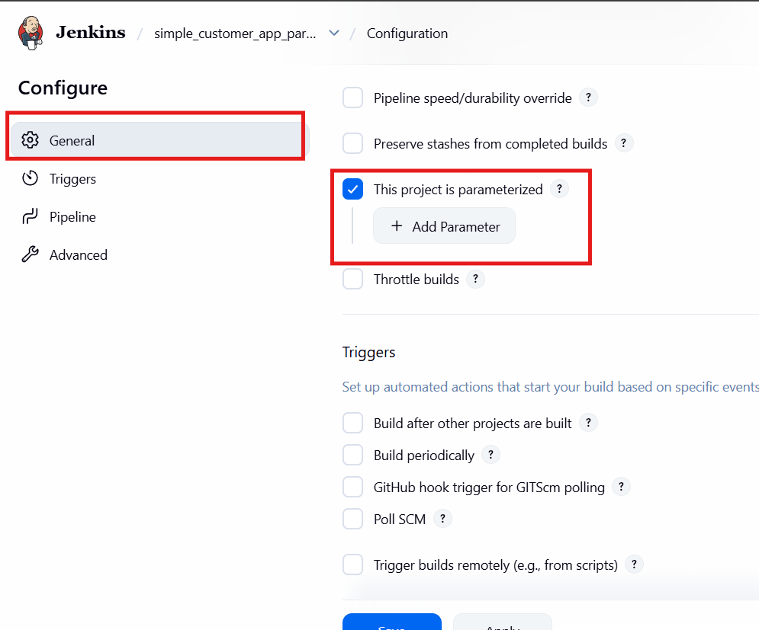
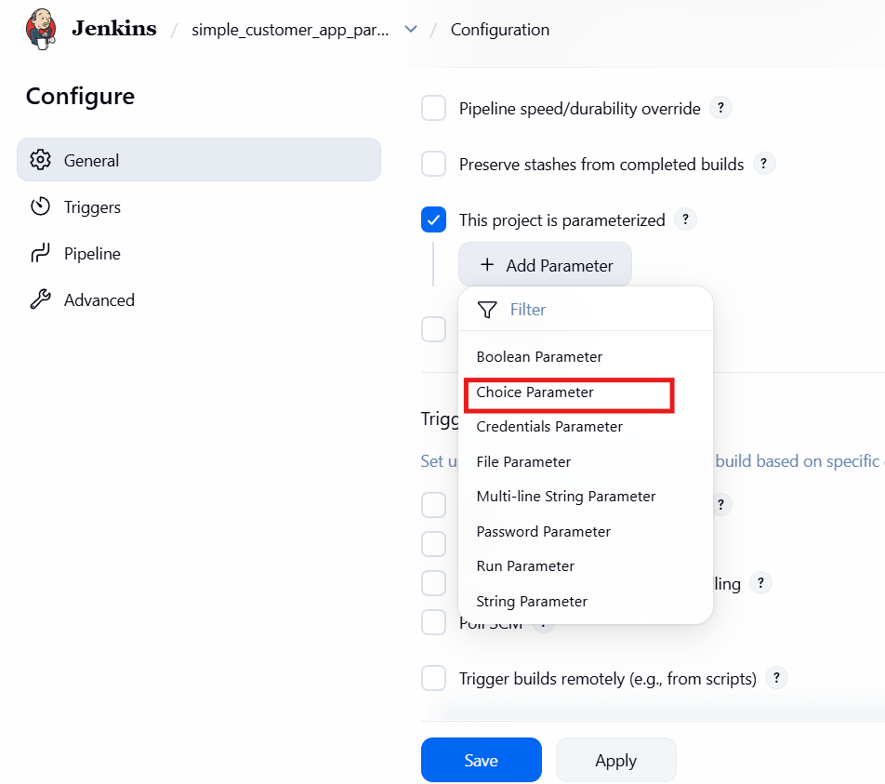
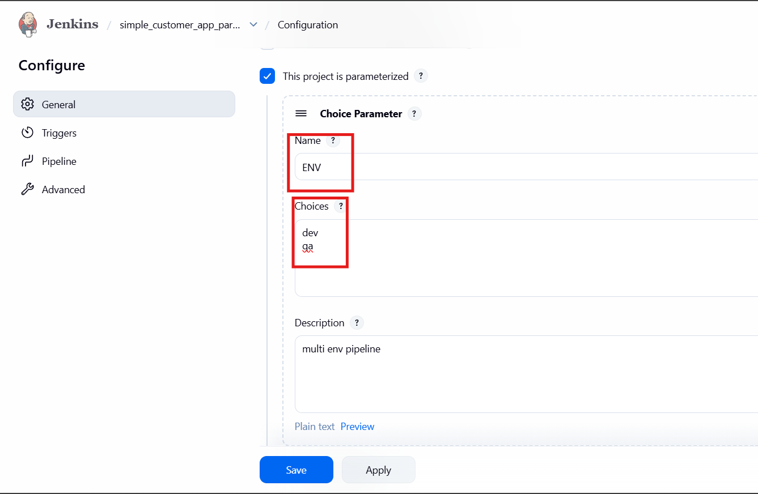
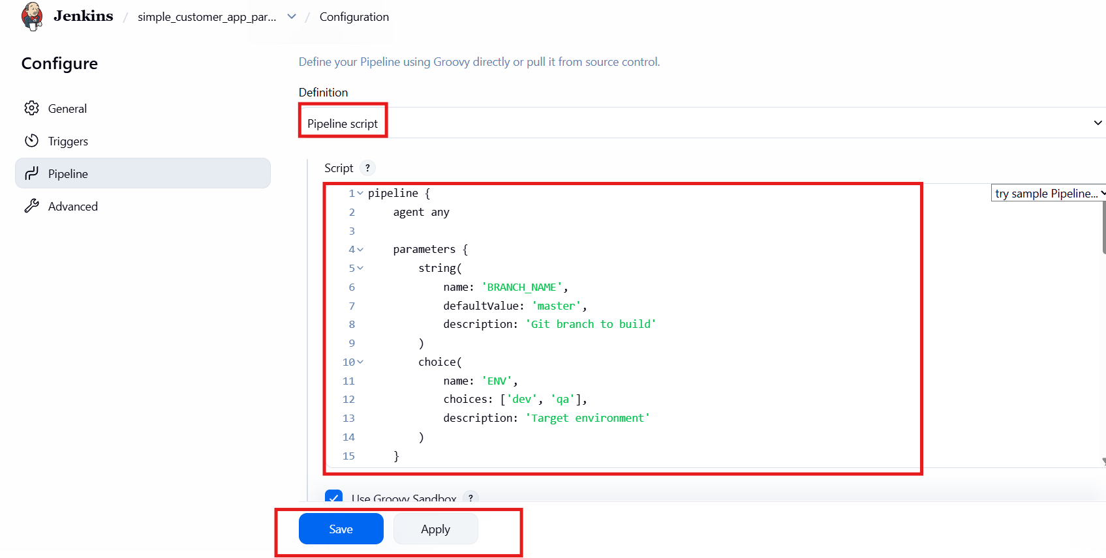

After saving it click on build to test the pipeline
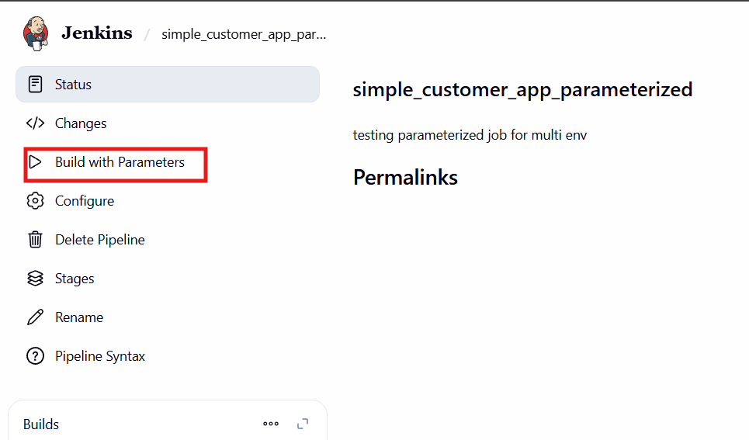

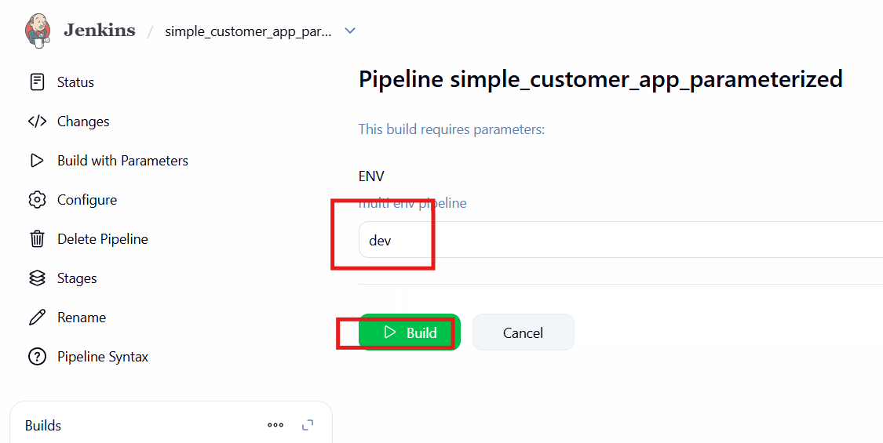

In slack also verified the build status
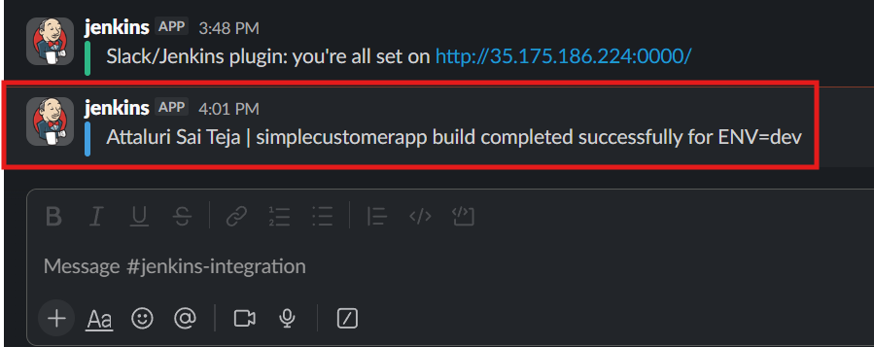
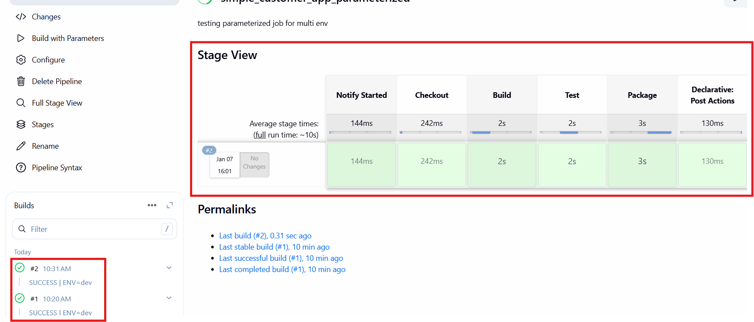
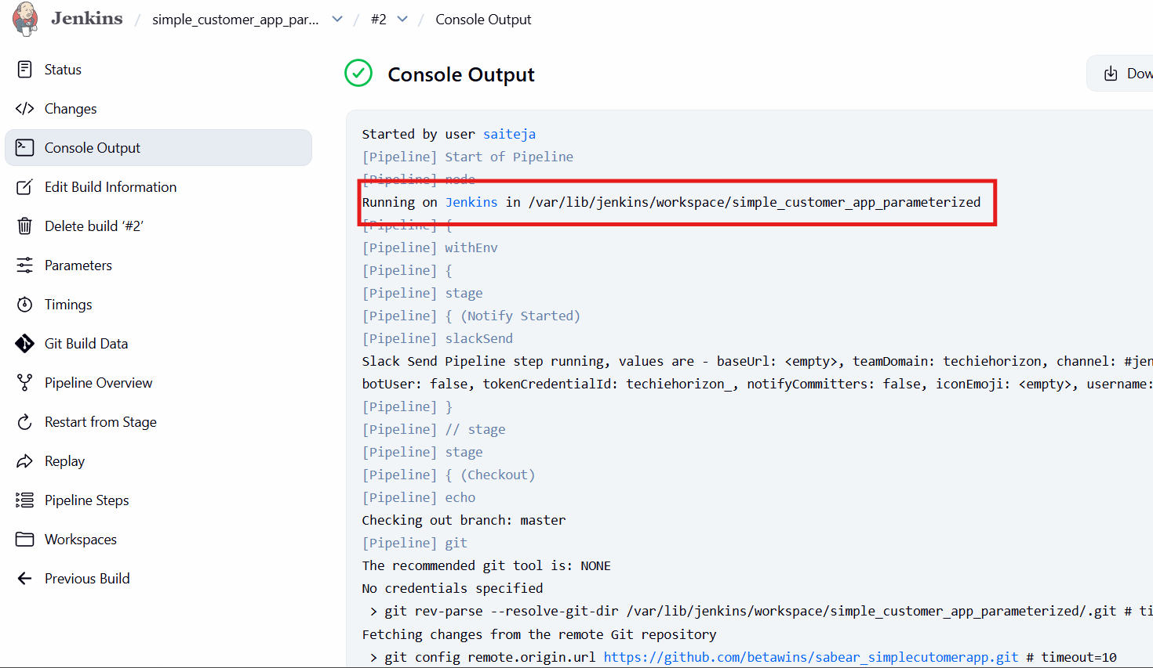
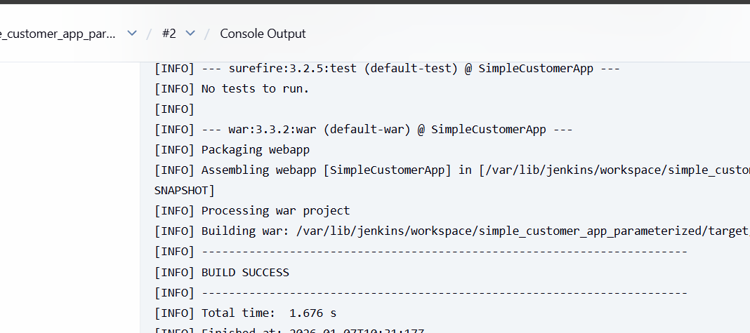
Later after executing a target file is created inside of workspace and verify the files and locate the inside of it
